PROJECT TITLE : TEA SELLING E-COMMERCE WEBSITE WEBPAGES

B:ADMIN SIDE WEBPAGES

B.1-> ADMIN DASHBOARD WEBPAGE

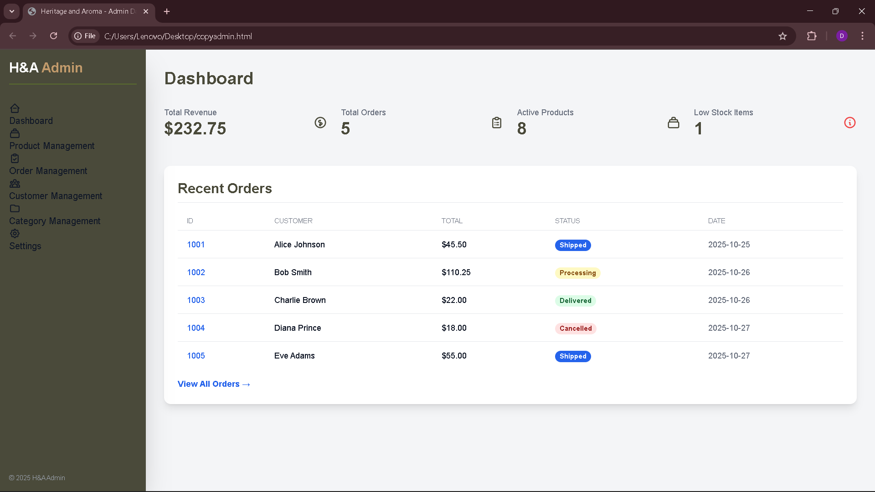

B.2->PRODUCT MANAGEMENT ADMIN SIDE WEBPAGE

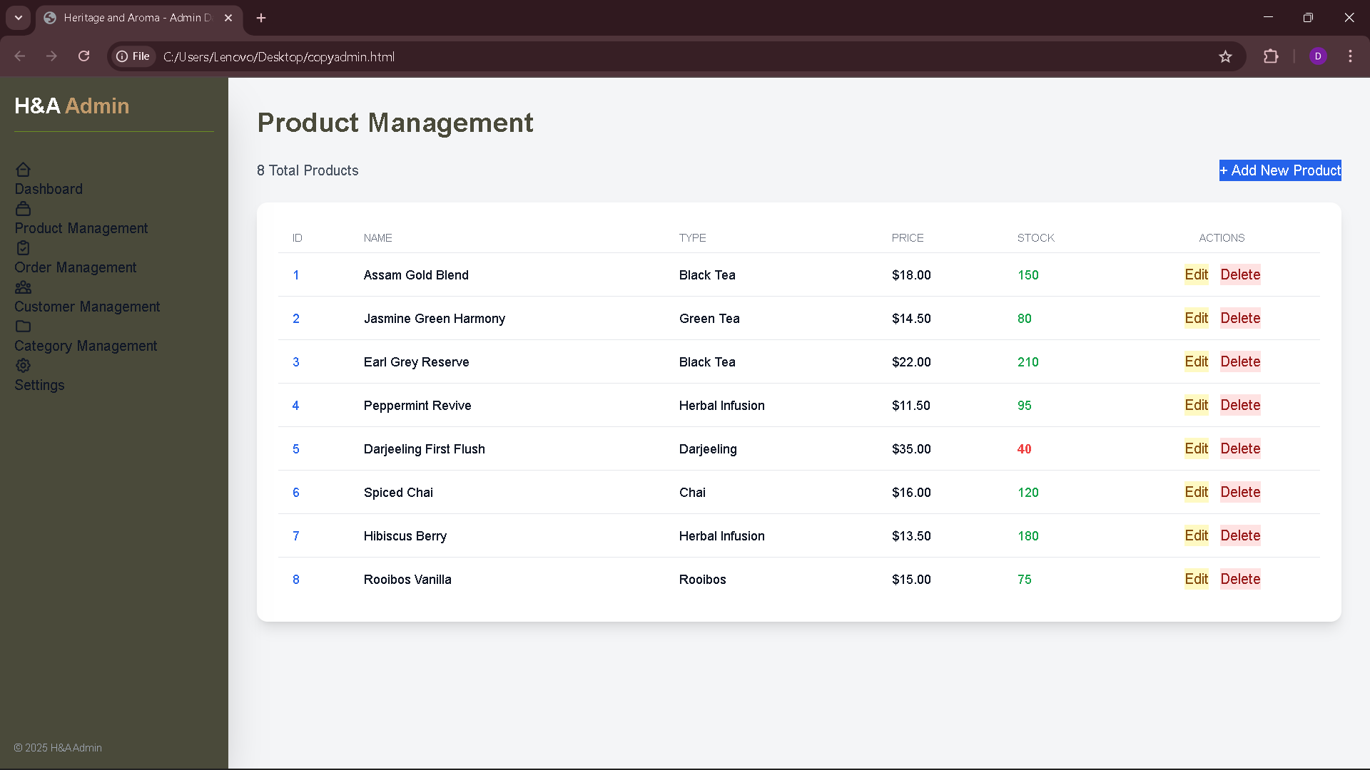

B.3->ORDER MANAGEMENT ADMIN SIDE WEBPAGE

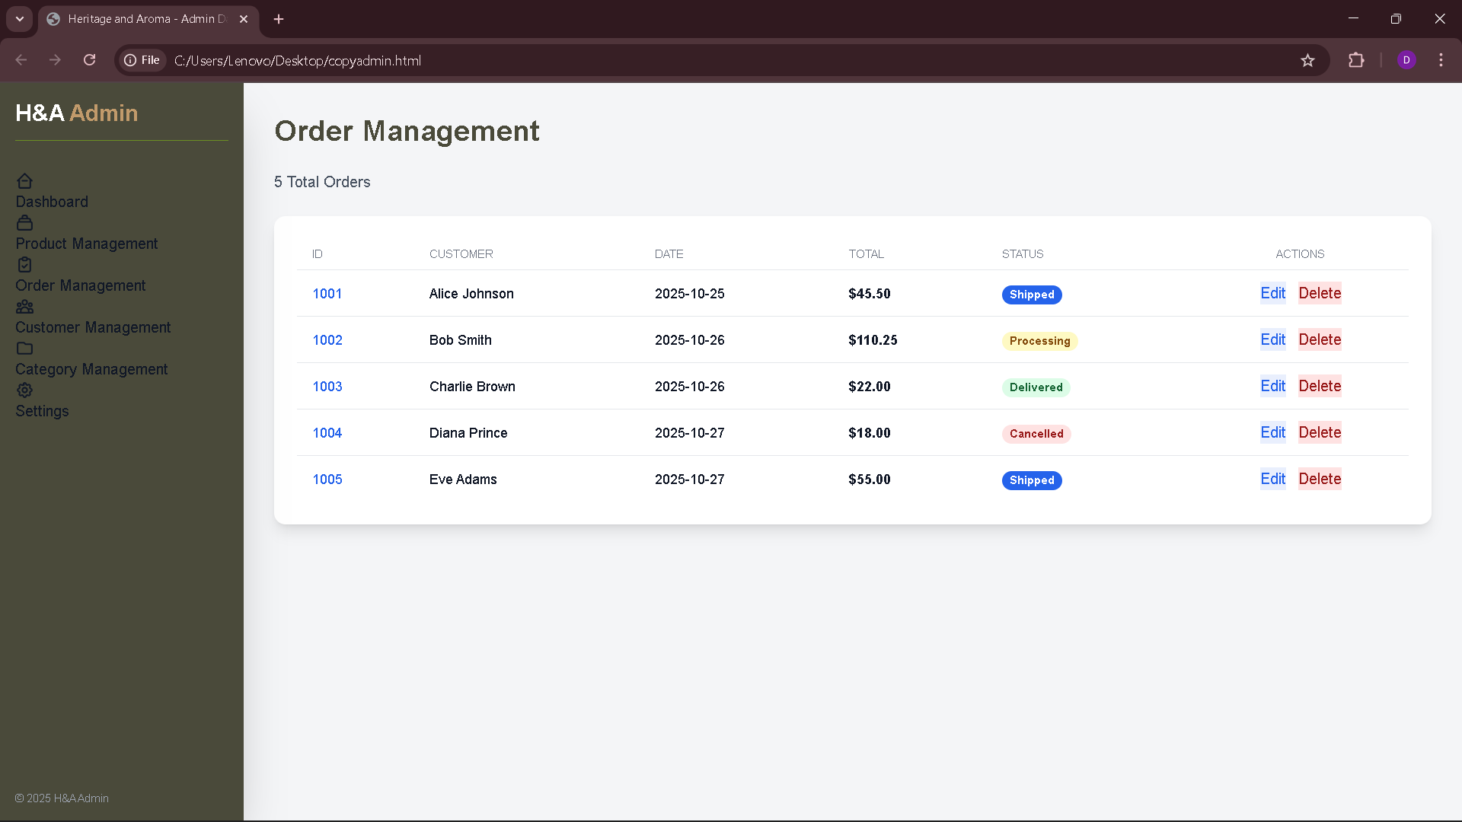

B.4->CUSTOMER MANAGEMENT ADMIN SIDE WEBPAGE

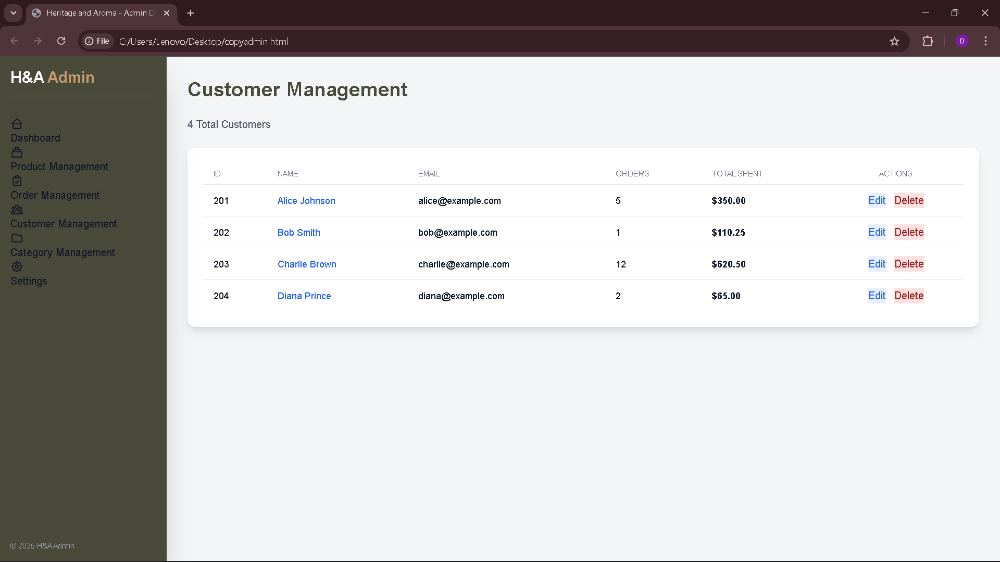

B.5->CATEGORY MANAGEMENT ADMIN SIDE WEBPAGE

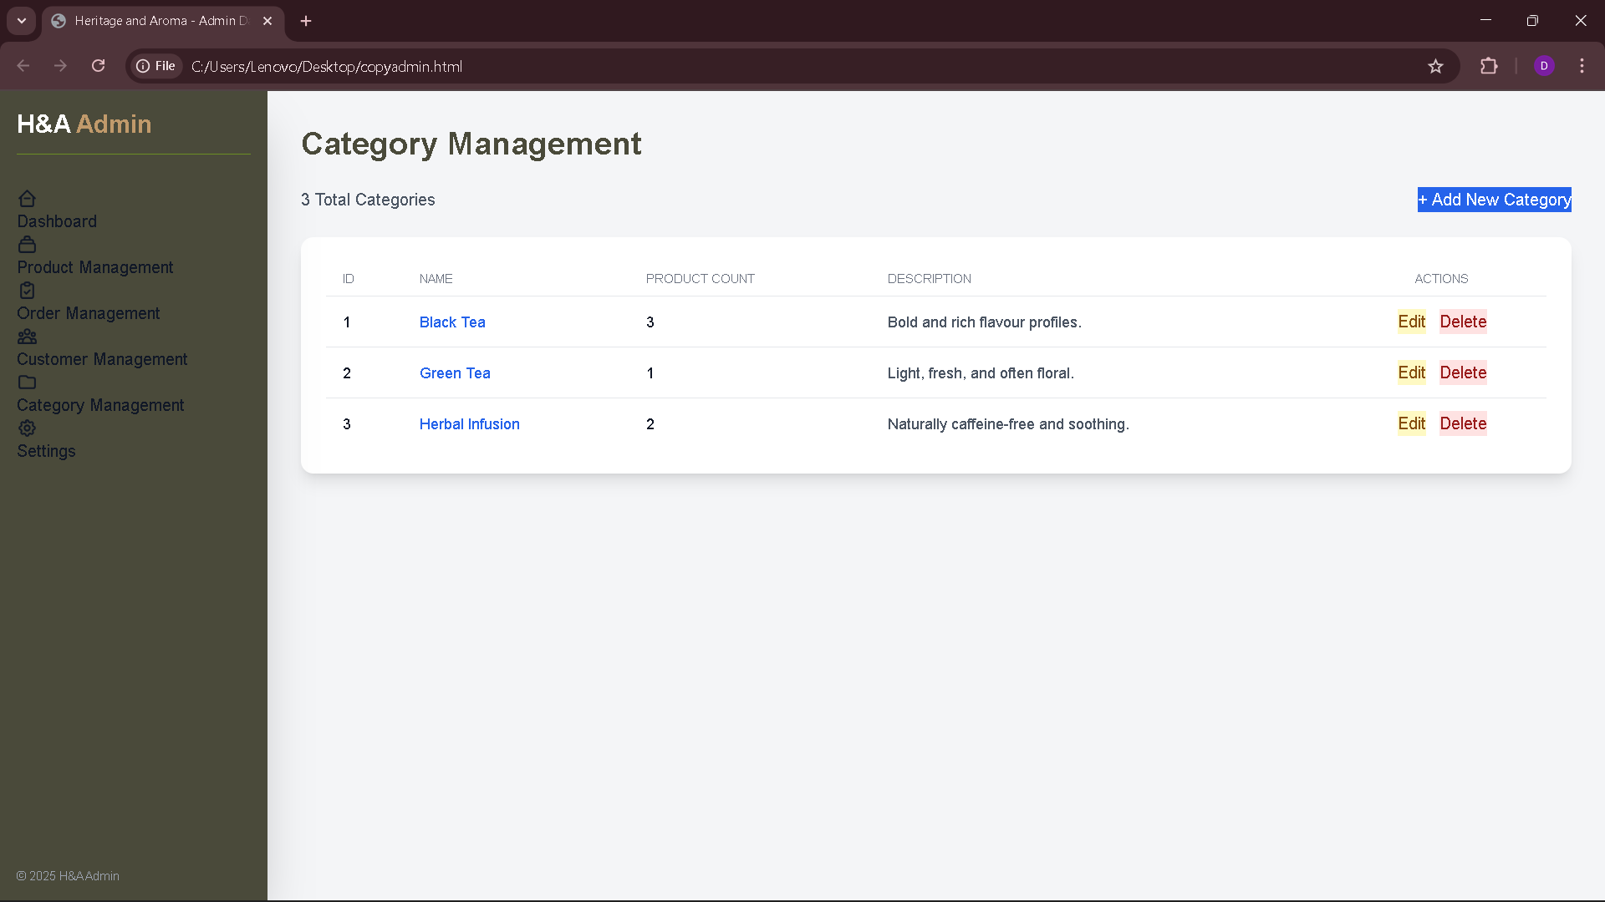

B.6-> ADMIN SETTING WEBPAGE

